# **Assignment 1- Analysis on CIFAR-10 Dataset**

The CIFAR10 dataset was classified using two:

* Multilayer perceptron
* Convolution Neural Networks

**Multilayer perceptron:**

CIFAR10 dataset was classified using MLP to predict the labels of new images. The prediction accuracy achieved ranged from 10% to 50% depending on various parameters influencing the model. The parameters were changed and the output was observed for different combinations of the data. When the batch-size, number of epochs and the density is increased, the accuracy improves. The best accuracy which could be achieved was 47%.

The output is as shown below:

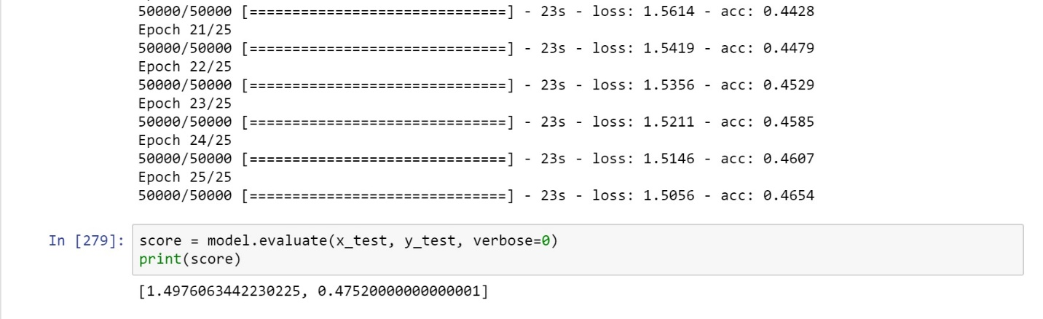

**Convolution Neural Network:**

The CIFAR10 dataset was classified using CNN and the result was an improvement over MLP. The prediction accuracy for just 1 epoch and batch size 10 was found to be 20%.

Additionally, on adding noise layers and Normalization layers to the model, the prediction accuracy further improved to 32%.

The model was tested for three kinds of noise layers:

* Gaussian Noise
* Gaussian Dropout
* Alpha Dropout

Gaussian Noise resulted in an overall prediction accuracy of 25% with just one epoch. Gaussian Dropout resulted in a better prediction accuracy of 29%. The best prediction accuracy was achieved while using alpha dropout which was 35%.

The results are as shown below:

The same models were tested for a randomly generated dataset from the CIFAR10 dataset. The new dataset had 12000 samples and the prediction accuracy was found to be 32% with gaussian dropout as an additional layer.

